EXPERIMENT 05

Consider titanic dataset and perform the following
Load the dataset to tableau by launching the Tableau Desktop and upload the dataset using text file as option and then select the desired sheet.
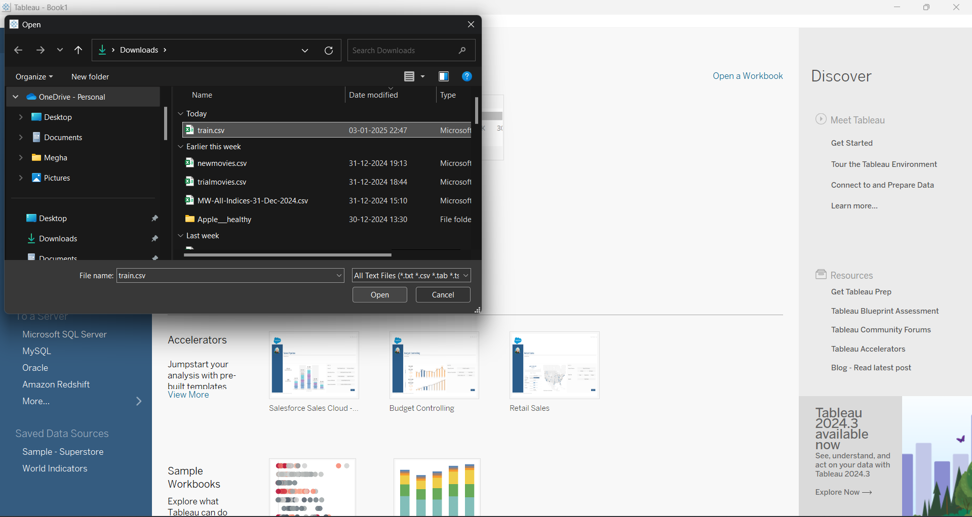
- Perform calculations:
- Calculate the survival rate using SUM(IIF([Survived] = 1,1,0))/COUNT([PassengerId])
Go to the Data Pane in Tableau. Create a Calculated Field. Name it Survival Rate. Enter the formula:
SUM(IIF([Survived] = 1, 1, 0)) / COUNT([PassengerId]). Drag this field to the Text or Detail shelf to display the survival rate.

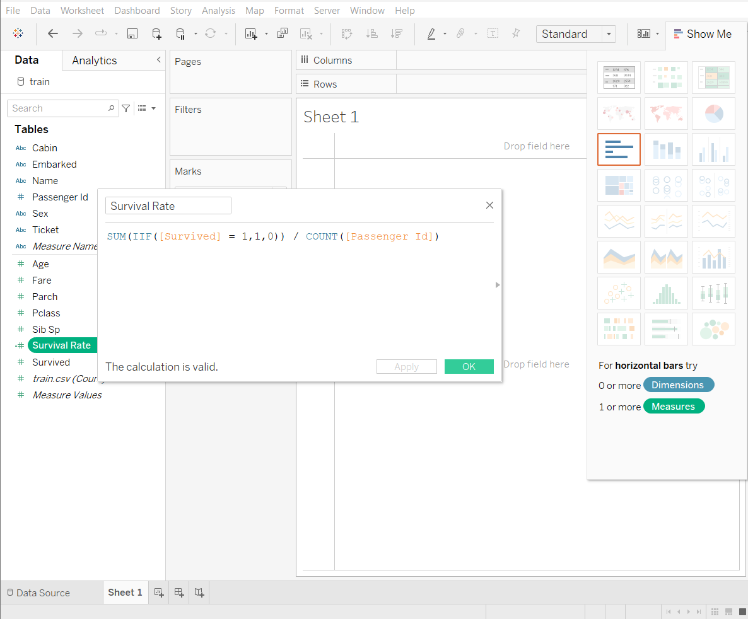

- Calculate the average
Drag the Age field to the Rows shelf. Right-click the field, select Measure, and choose Average. Rename the field as Average Age.
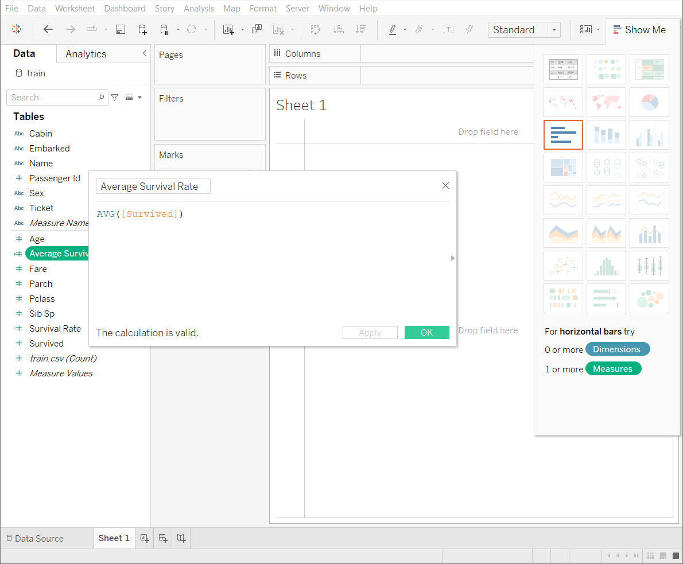

- Calculate the total fare
Drag the Fare field to the Rows shelf. Right-click the field, select Measure, and choose Total. Rename the field as Total Fare.
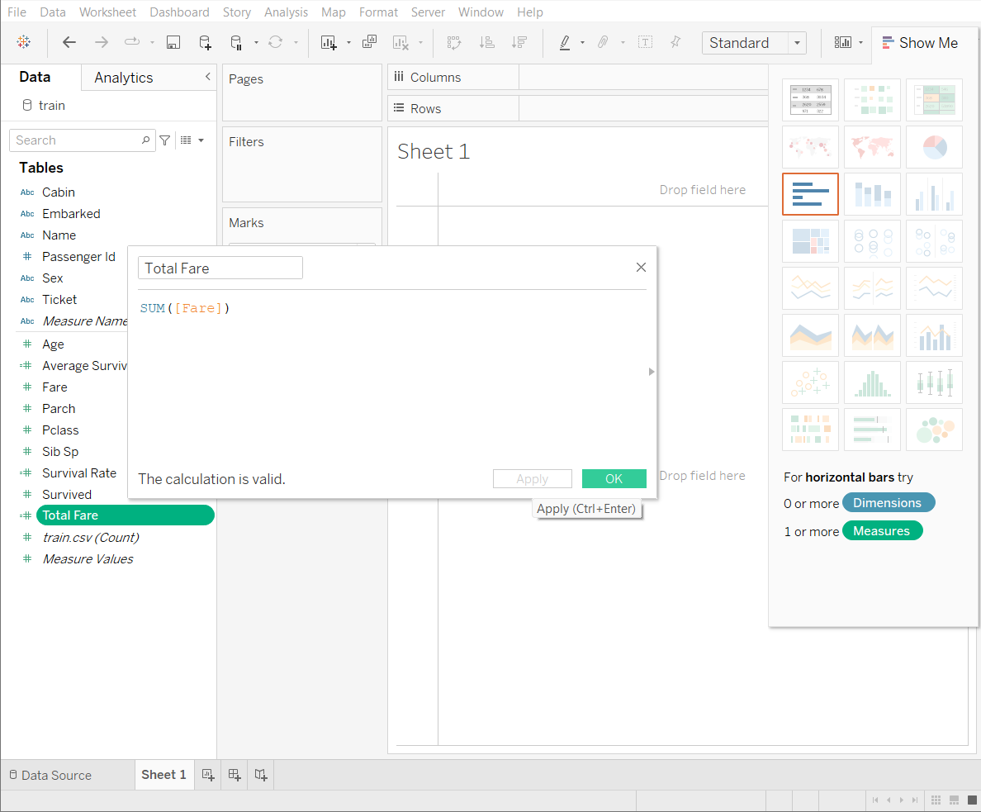

- Perform group operations
- Create a group to categorize passengers by age
Right-click on the Age field and choose Create > Bins. Set bin size (e.g., 10 years) or manually specify ranges: Children: 0–12 Teenagers: 13–19 Adults: 20–59 Seniors: 60+. Name it Age Groups.
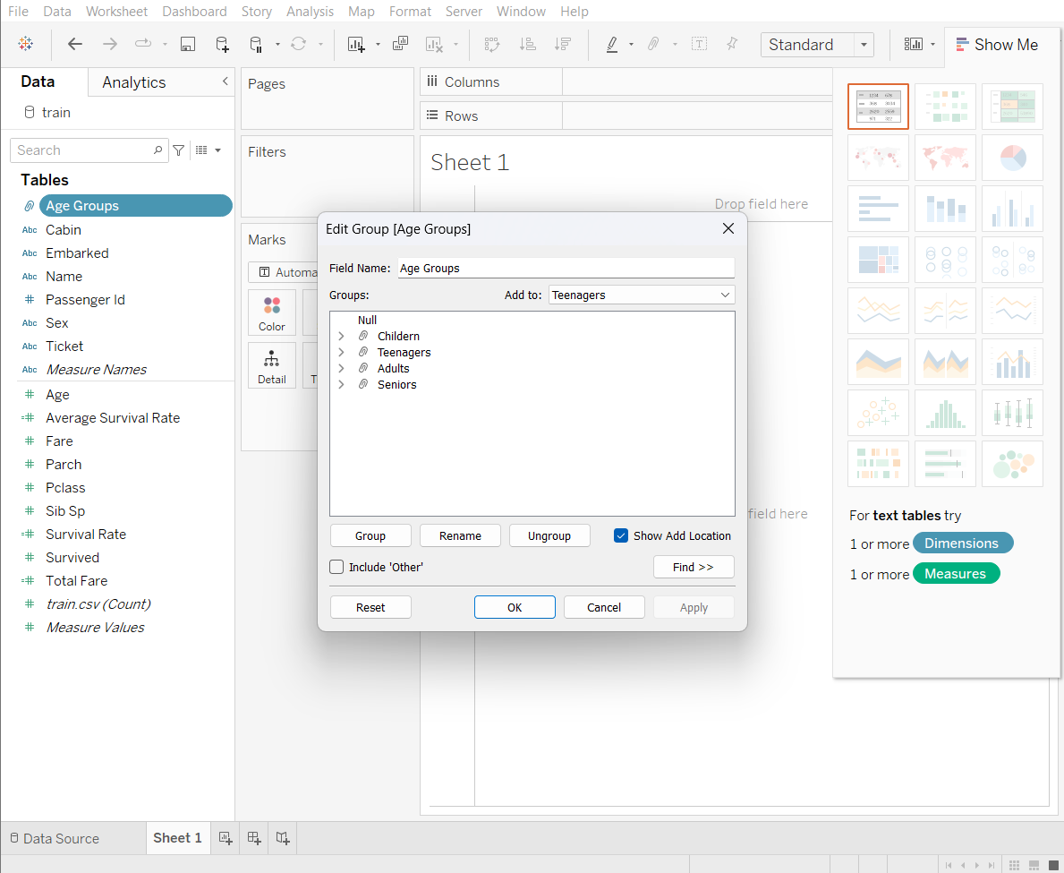

- Create a group to categorize passengers by fare
Right-click on the Fare field and choose Create > Bins. Set appropriate bin sizes (e.g., 0–50, 51–100, 101–200, etc.). Name it Fare Groups.
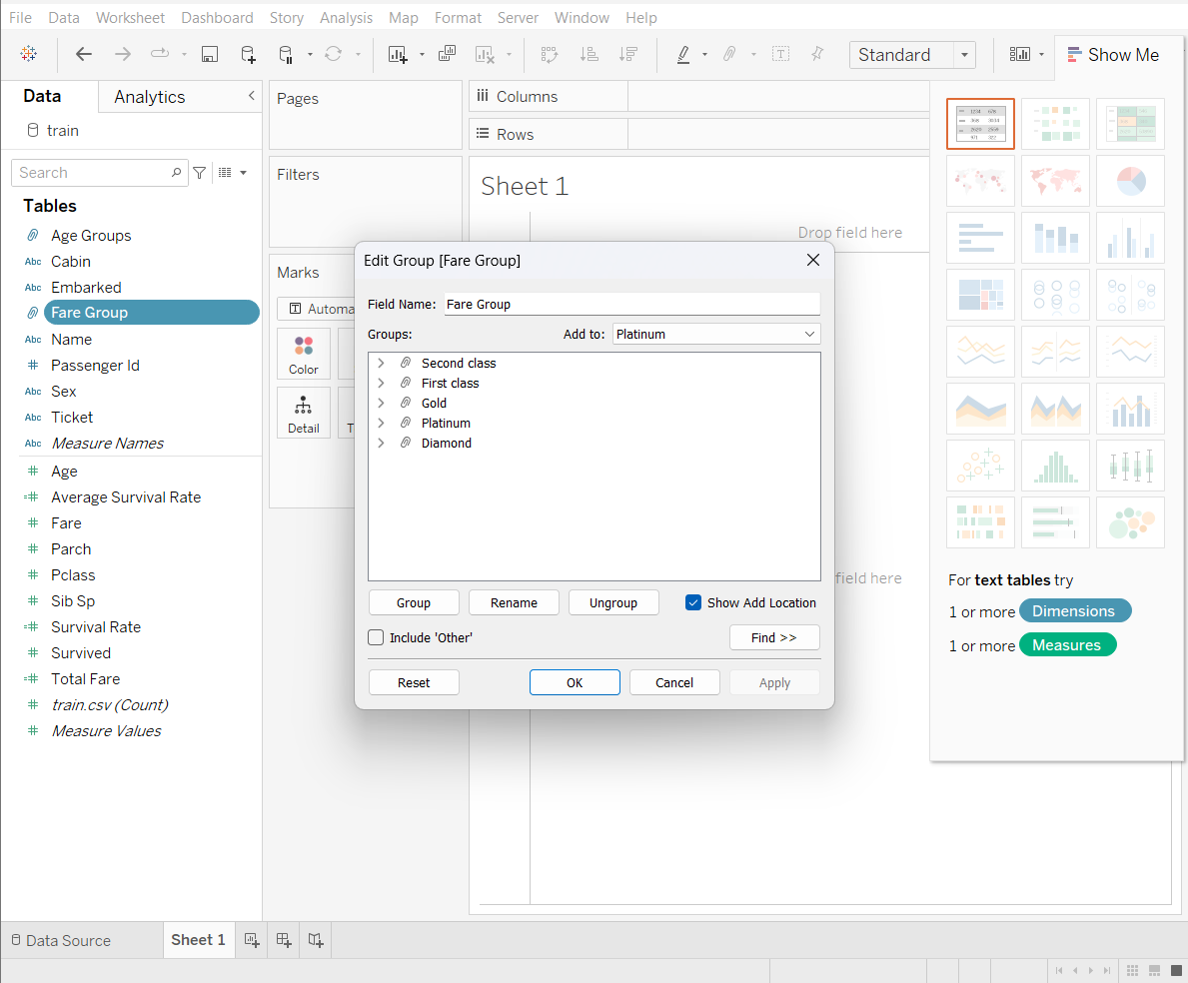

- Create a set to include only passengers who survived
Right-click on the Survived field and choose Create > Set. Set the condition as Survived = 1. Name it Survived Set.
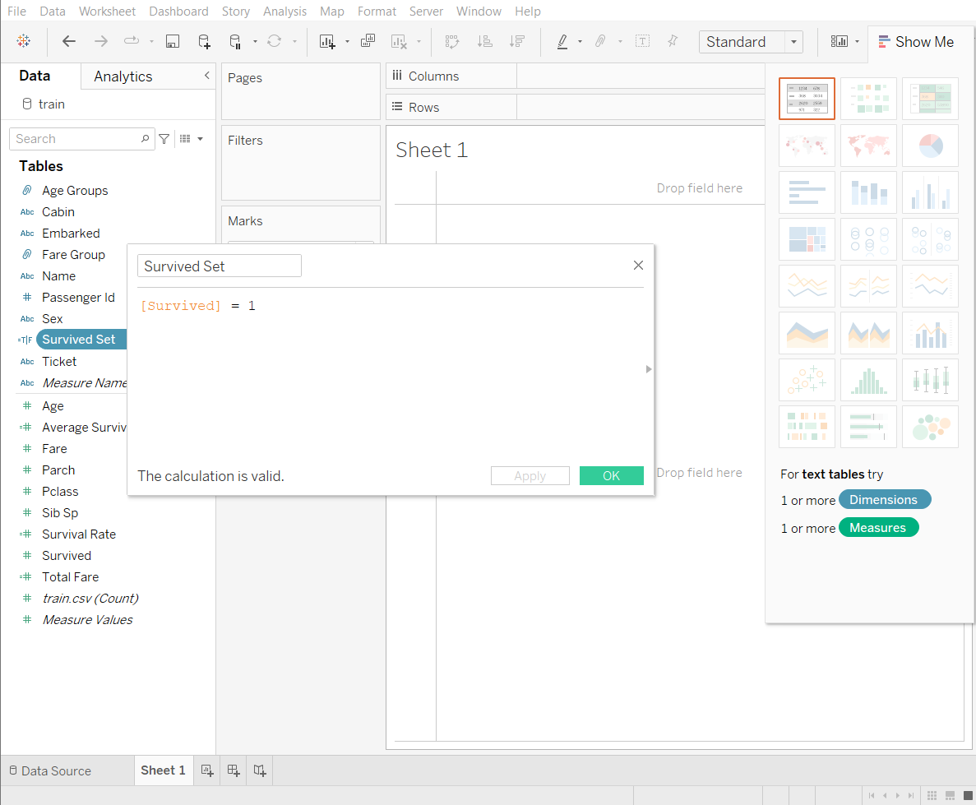

- Perform set operations
- Create a set to include passengers who survived
Create a set for survivors by right-clicking the Survived field, selecting "Create > Set," and setting the condition Survived = 1. Name it Survived Set. This set is essential for analysing trends or visualizing data specific to survivors.

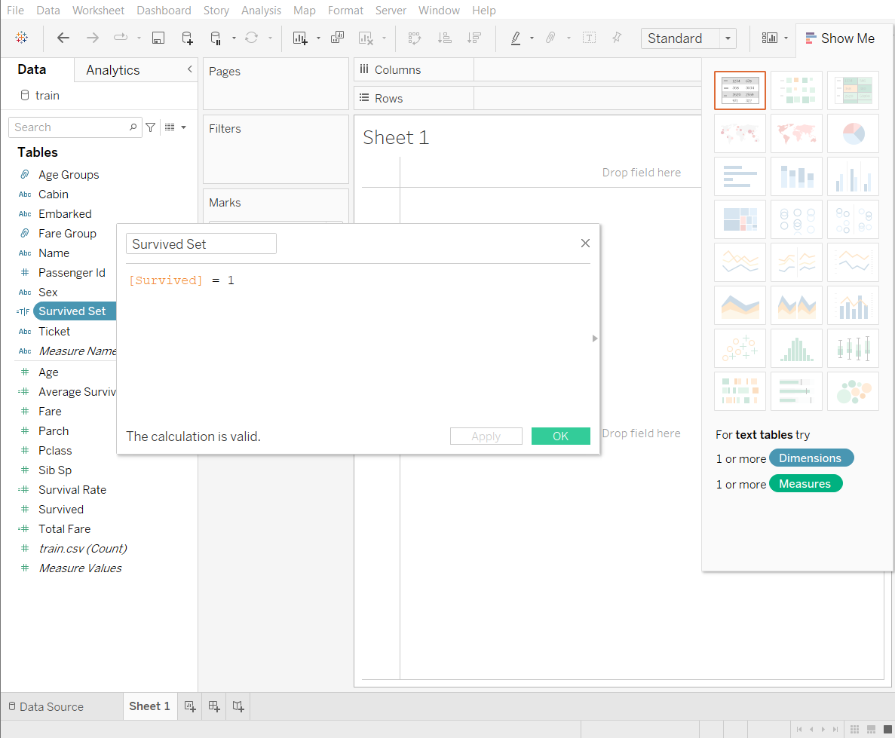

- Create a set to include passengers who did not survive
Right-click on the Survived field and choose Create > Set. Set the condition as Survived = 0. Name it Non-Survived Set.
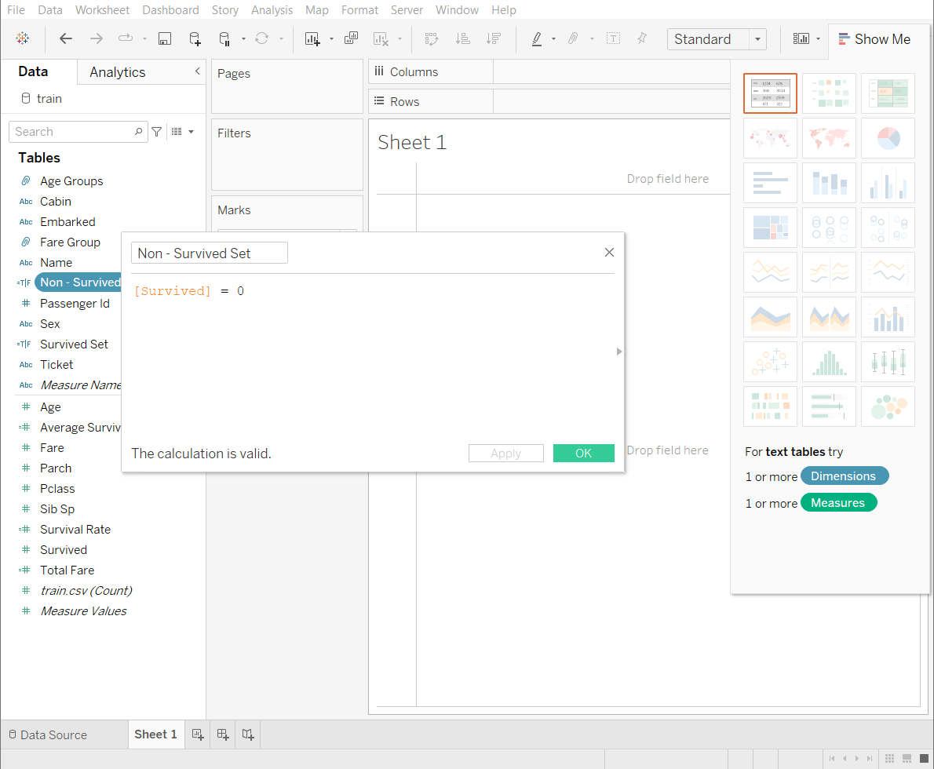

- Create dashboard
- Survival rate by age group - Create a bar chart to represent survival rate by age group
Drag Age Groups to the Columns shelf. Drag Survived to the Rows shelf and select Average as the aggregation. Convert it to a Bar Chart. Rename the chart to Survival Rate by Age Group.
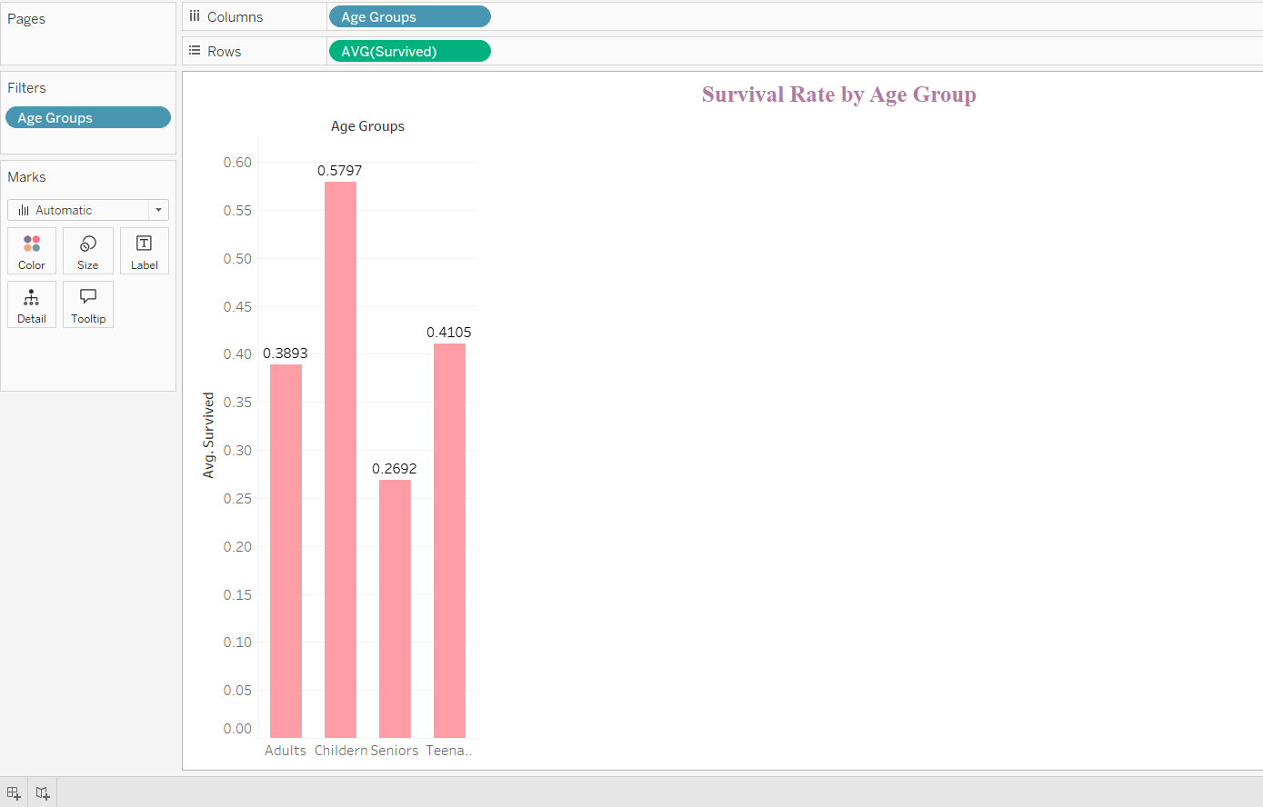

- Average fare by fare group - Create a bar chart to represent average fare by fare group
Drag Fare Groups to the Columns shelf. Drag Fare to the Rows shelf and select Average as the aggregation. Convert it to a Bar Chart. Rename the chart to Average Fare by Fare Group.
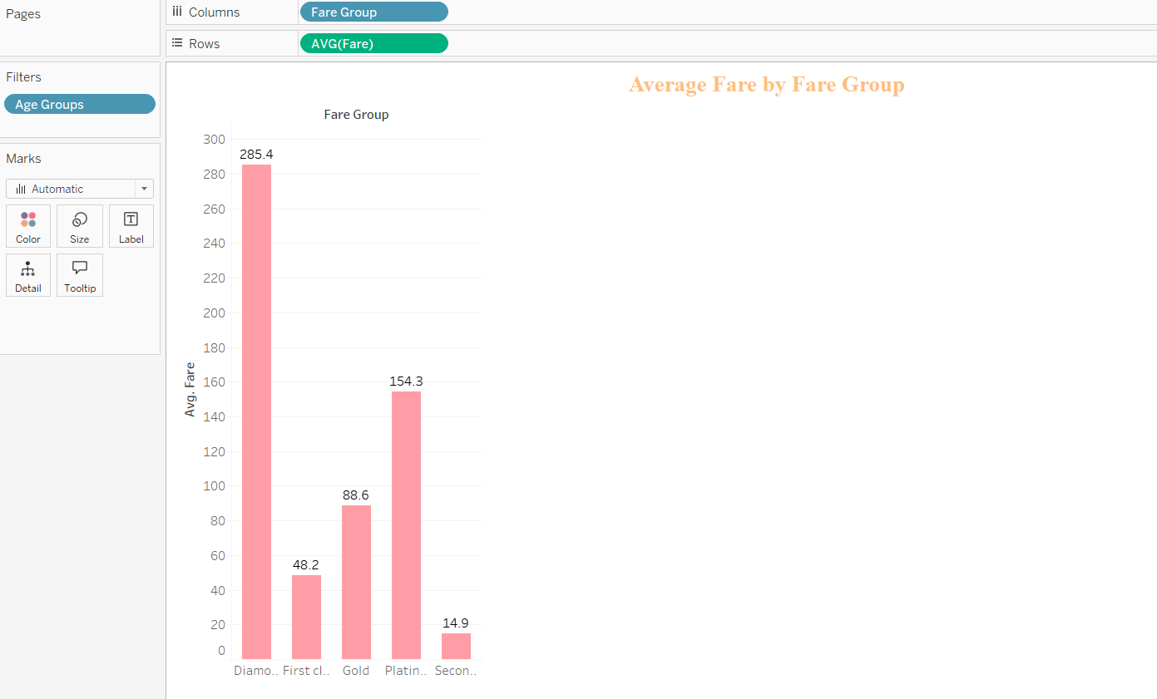
- Survivors by class – Create a pie chart to display number of survivors by class
Drag FareGroup to the Columns shelf. Drag Survived to the Rows shelf. Convert it to a Pie Chart using the Marks card. Filter the chart for only survivors using the Survived Set.
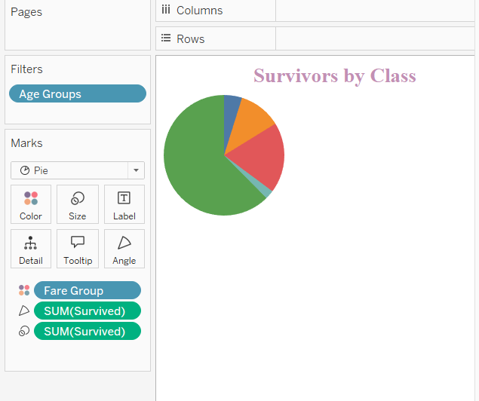

- Add additional visualizations
When designing additional visualizations, focus on clear and relevant chart types, such as histograms for distributions and bar charts for comparisons. Maintain consistent colours, fonts, and styles, using annotations and tooltips to highlight key insights like survival rates or fare trends. Add interactivity with filters and dropdowns to explore data dynamically, ensuring a balanced and intuitive layout. Group related charts logically, and include clear titles and legends to make the visuals self-explanatory and impactful.

- Combine dashboards.
Combine all visualizations into a single dashboard. Drag and drop each chart into the dashboard workspace, arranging them logically. Add interactivity by including filters for age groups, fare groups, and class to allow users to explore different aspects of the data. Ensure the layout is clear and visually appealing for effective storytelling.

